Computer Vision

Assignment 0

Name: Harshit Aggarwal

Roll Number: 2021111015

Problem 1:

This problem deals with conversion of video into frames and how to merge frames to get a video. We need to get the particular frames from a video as specified. The solution uses the videocapture and videowriter functions from opencv library to get the frames. The code for the same is the following:

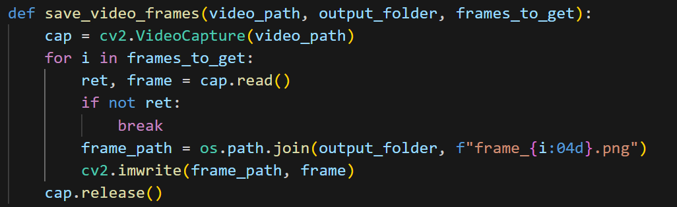

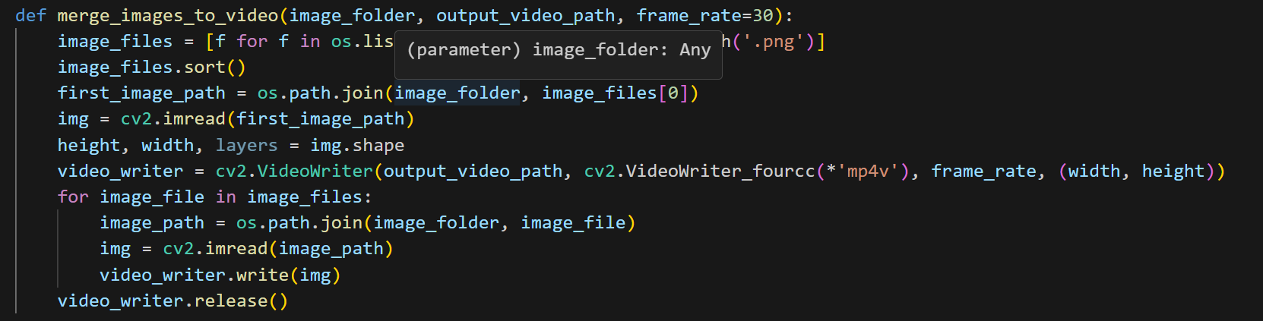

I got the following frame from an eye tracker video:

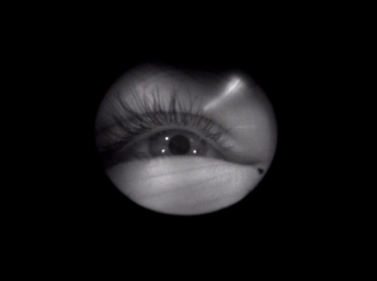

From this problem, I learned the basics of opencv Library and the use of videocapture and videowriter functions.

Problem 2:

This problem basically deals with how to capture frames from the video camera of the computer and save it while also displaying it on the screen simultaniously. This problem is also solved using the videocapture function from the opencv library. If we give the input as 0 to the function, then it uses the video camera of the device to get the video frames. Then I just display them on a screen and store them in a folder. The code for the same is given below:

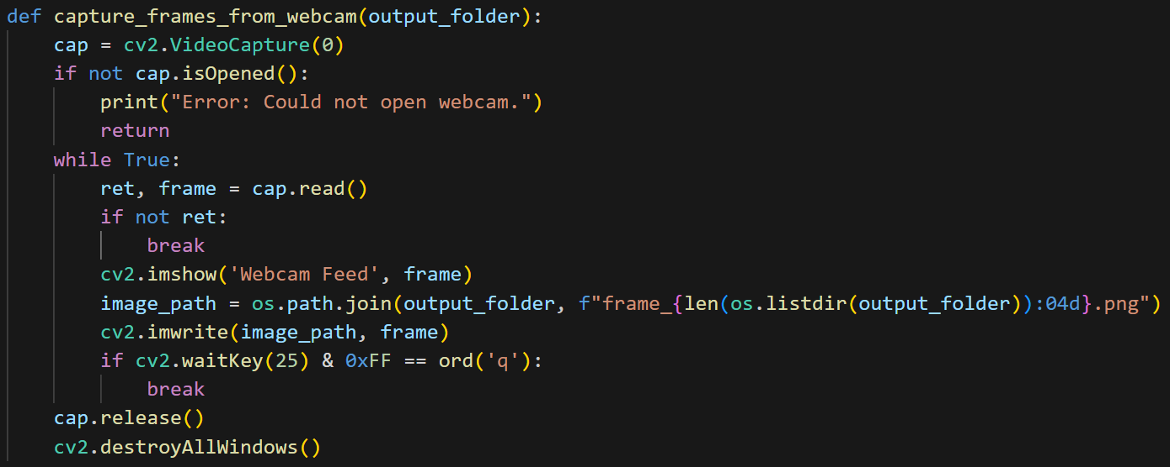

One of the resulting frames which I got was:

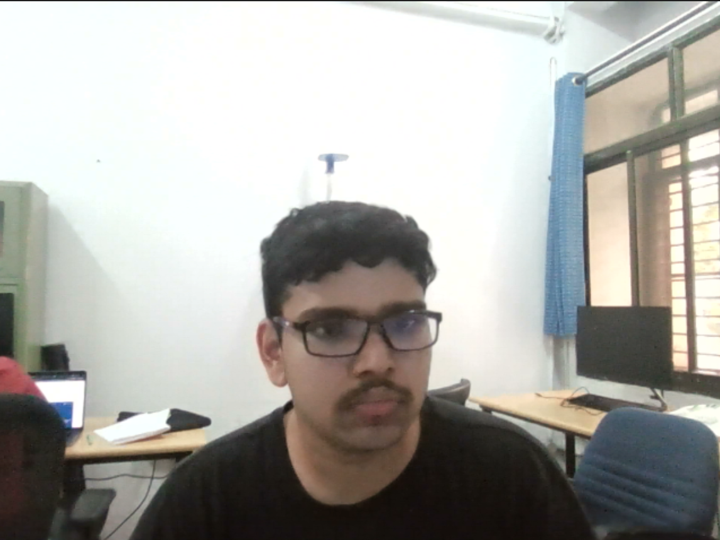

Here, I learned how to get frames from the video camera of the device.

Problem 3:

This problem deals with chroma keying. This basically means that we will have two videos as inputs out of which one will have a green screen and we need to remove the green screen and add the other video there. For doing this, we apply a very basic digital image processing technique which solves this problem by making masks. For all the frames, we make masks which is the green region of the frame. Now, we delete this region from the foreground and delete the inverse of the mask from the background. Now, we just add both the foreground and the background to get the final frame of the combined video. The code for the same is given below:

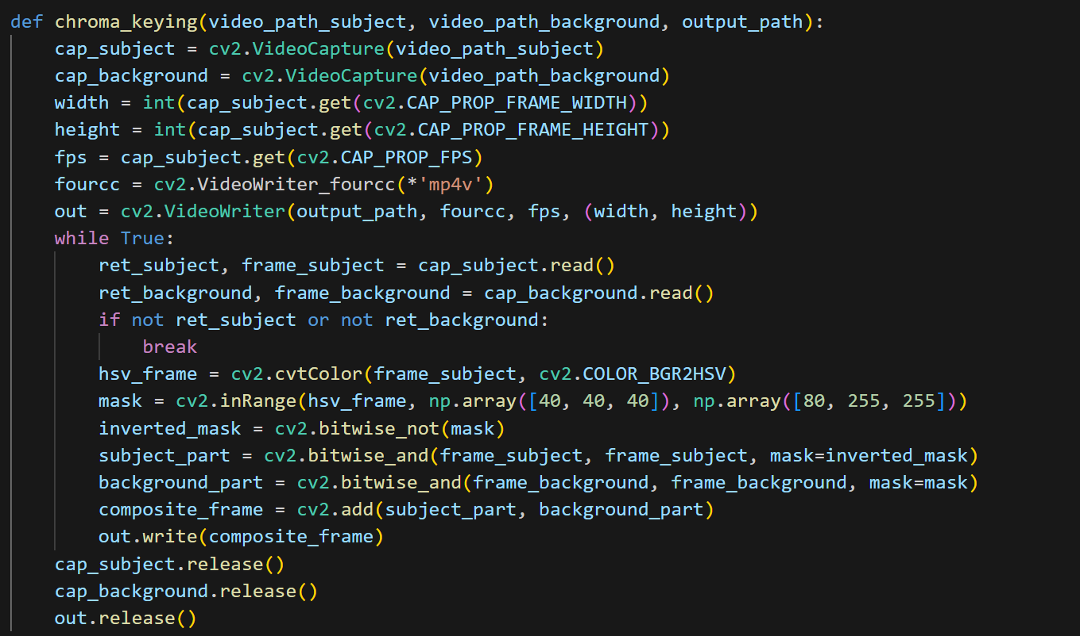

One of the output frames here where:

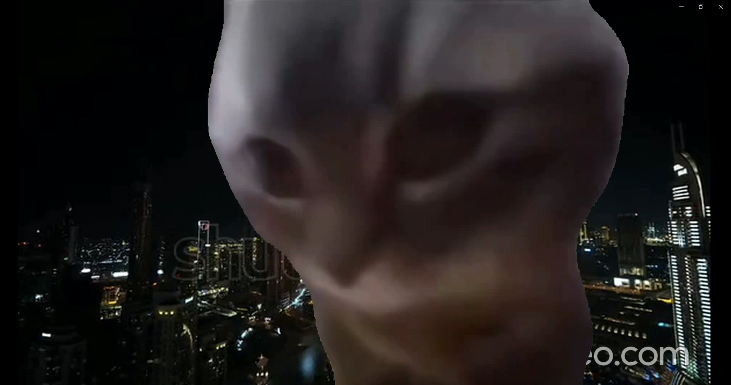

Where the original video contained frames of the form of:

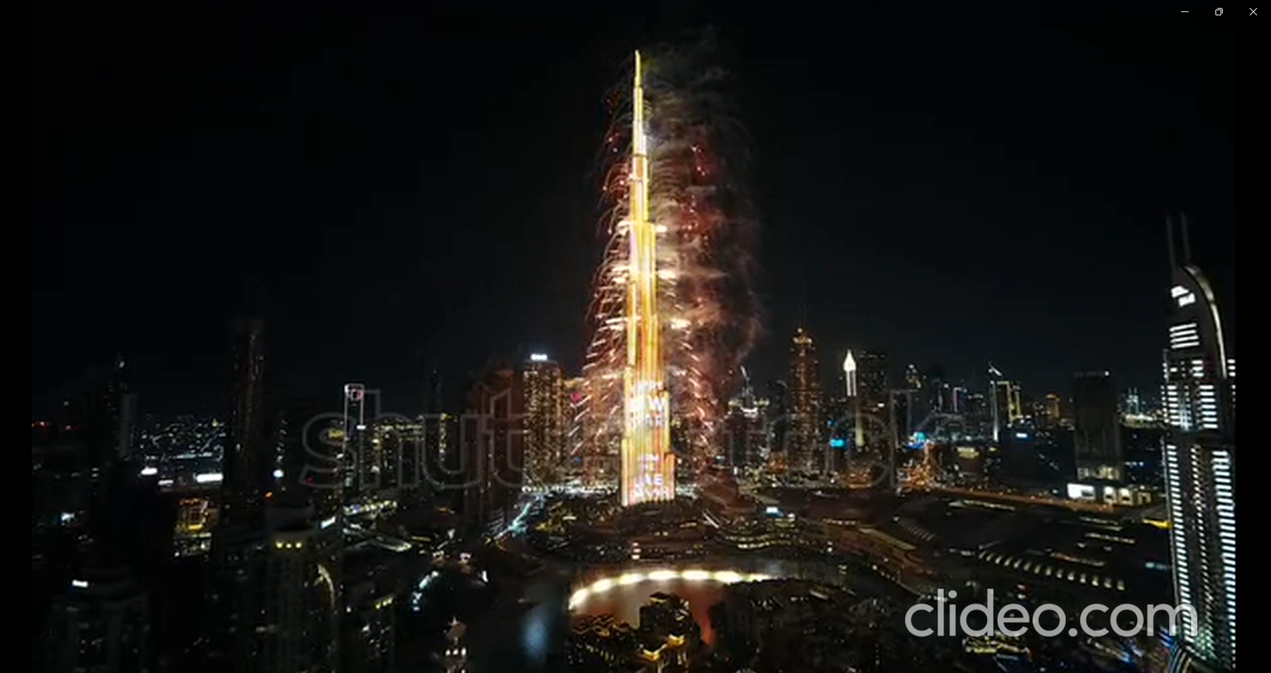

As the background and

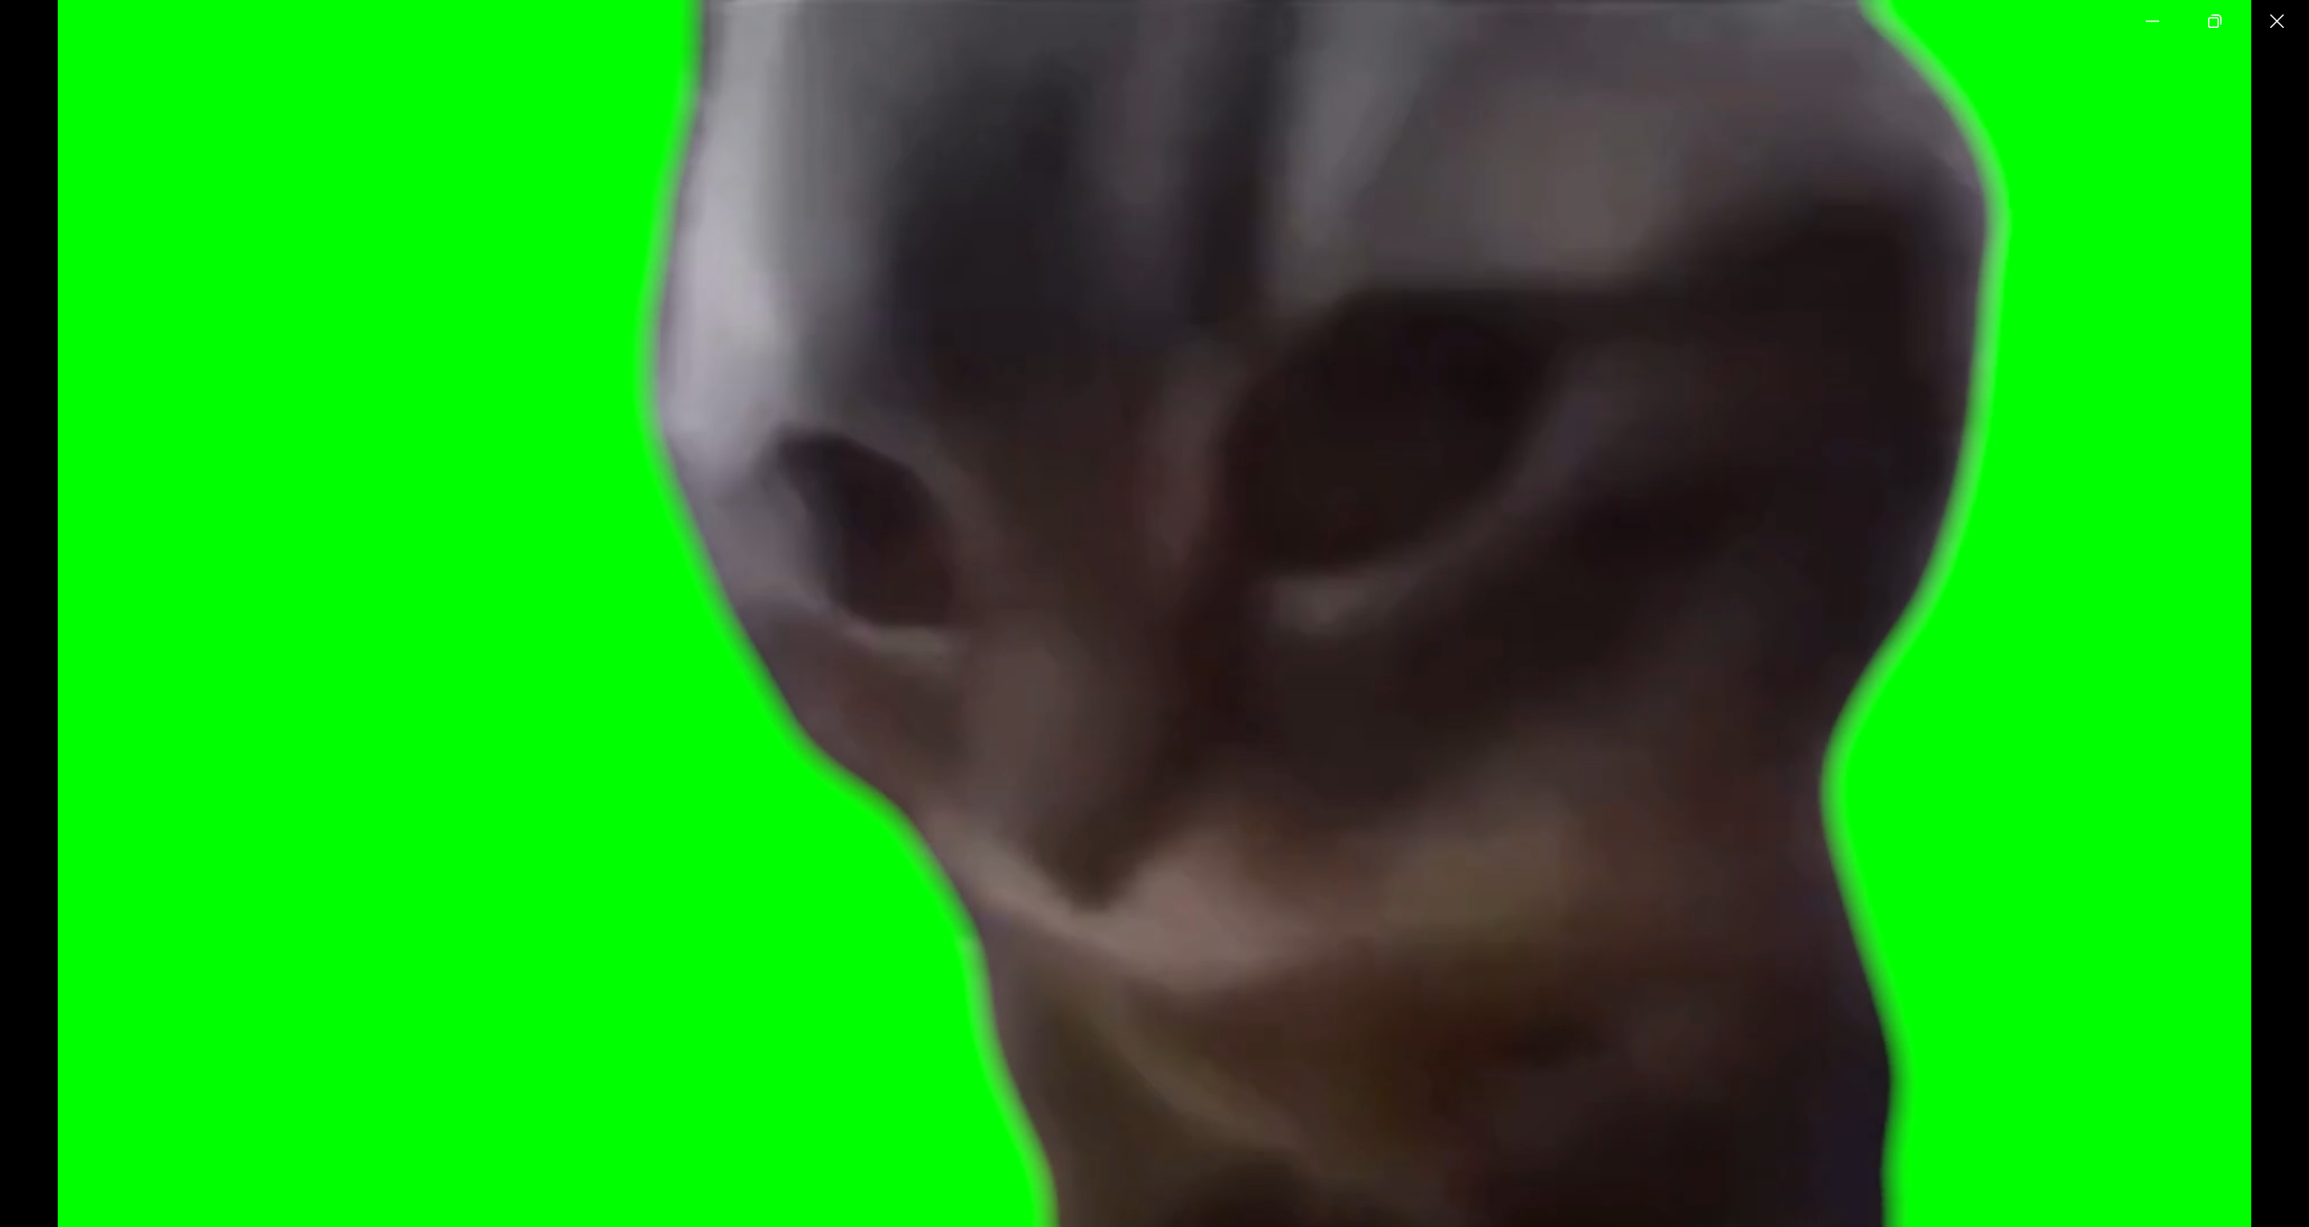

As the foreground.

The main challenge I faced was to figure out the way to remove the green screen and add the background there but the knowledge from the digital image processing course came in handy there and thus I was able to figure out the mask method.